**New Build Pipeline Steps**

1. Source = TFVC/Git
2. Start with an Empty Job
3. Add Agent Tasks
   * 1. Add VSBuild Task
        1. Select SLN/Solution File from your Repo
        2. Set MSBuild Arguments for SQLPackage
        3. Platform – Any cpu
        4. Config – release
     2. Add Copy Files Task
        1. DisplayName - Copy Files to: $(build.artifactstagingdirectory)
        2. Source Folder - $/SQL Server/DatabaseProjects/DevOpsDemo/AWLT
        3. Contents - **\bin\**
        4. Target Folder - $(build.artifactstagingdirectory)
     3. Add Publish Build Artifact
        1. Display Name - Publish Artifact: AW_LT
        2. Path to Publish: $(Build.ArtifactStagingDirectory)
        3. Artifact Name: AW_LT
        4. Artifact publish location: Azure Pipelines

**New Release Pipeline Steps**

1. Add Artifact (input)
   1. Select Project
   2. Select Source
   3. Default version – Latest
   4. Source Alias – leave
2. Add Stage
   1. Rename Stage to Prod
   2. Add Empty Job
   3. Click 1 Job, 0 Tasks
   4. Edit Job Properties, under Demands, add sqlpackage/exists
   5. Add Tasks to Agent Job
      1. Select Azure SQL DacPac Task – blue cloud
      2. Set Task properties
         1. Azure subscription
         2. Auth Type – SQL
         3. SQL Server - insyncva.database.windows.net
         4. Database – use variable
         5. Login – use variable
         6. Password – use variable
         7. Deploy Type- SQL DacPac file
         8. Action – Publish
         9. DacPac File – browse to dacpac
         10. Publish Profile – empty
         11. Additional SqlPackage.exe Arguments
             1. /p:DatabaseEdition=Basic is the Product SKU

**Variables**

Variables are useful when you create many pipelines, pipelines via automation or via YAML

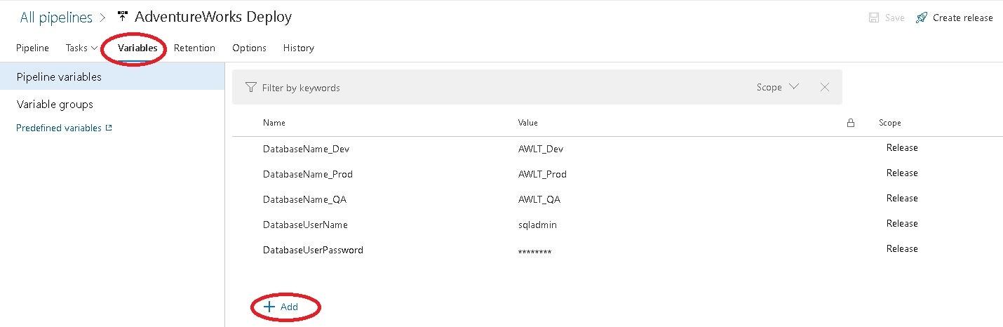

The list of pre-defined pipeline variables is here:

<https://docs.microsoft.com/en-us/azure/devops/pipelines/build/variables?view=azure-devops&tabs=yaml>

The most common variable is $(build.artifactstagingdirectory)

**CI/CD Trigger**

The Trigger lives on the Release Pipeline Artifact

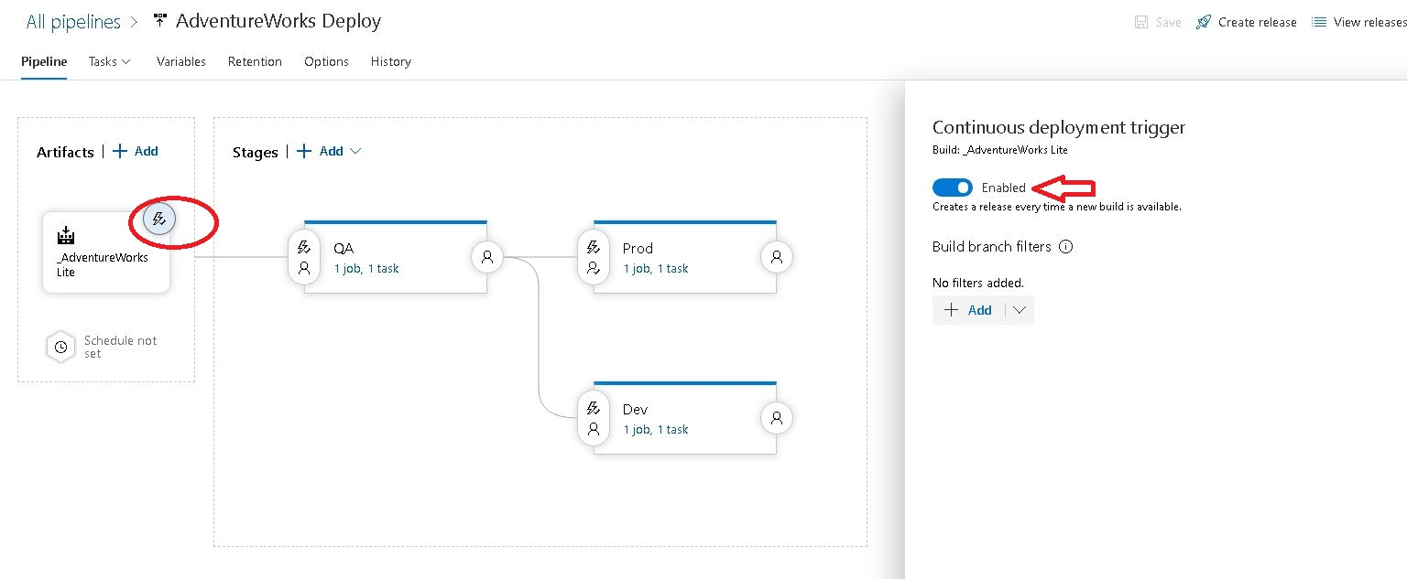

**Pre-Post Deployment Approvals – Sends an Email**

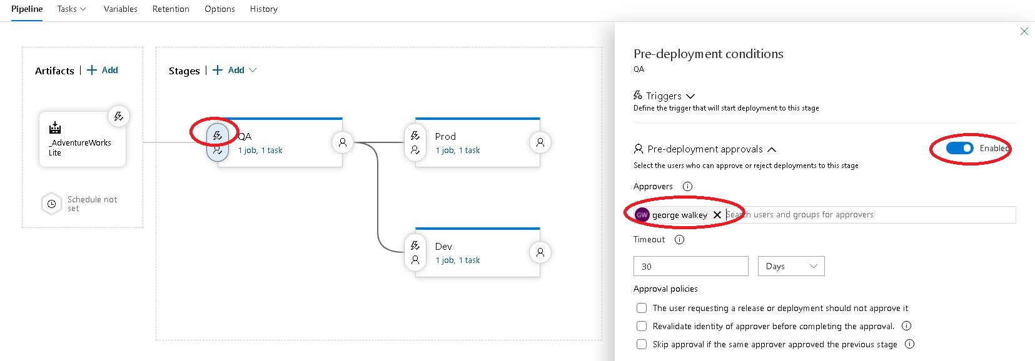

**Build Pipeline – Arguments**

**MSBuild arguments**

/p:DeployOnBuild=true

/p:WebPublishMethod=Package

/p:PackageAsSingleFile=true

/p:SkipInvalidConfigurations=true

/p:PackageLocation="$(build.artifactstagingdirectory)\\"

/p:DropObjectsNotInSource=false

**Copy File Task Args**

Display Name: Copy Files to: $(build.artifactstagingdirectory)

Contents: **\bin\**

Target Folder: $(build.artifactstagingdirectory)

**Publish Build Artifact Args**

Display Name: Publish Artifact: AW_LT

Path To Publish: $(Build.ArtifactStagingDirectory)

Artifact Name: AW_LT

Artifact publish location: Azure Pipelines

**Release Pipeline – DacPac Task Args**

Azure Sub - pick your subscription

Azure SQL Server: sqlservername.database.windows.net

Database: $(DatabaseName_Prod)

Login: $(DatabaseUserName)

Password: $(DatabaseUserPassword)